Using Models to Understand Photosynthesis

1. Add to this drawing to show what you already know about photosynthesis. Try to include the inputs needed for photosynthesis and the outputs produced by photosynthesis.

Write any questions you have about photosynthesis.

To learn more about photosynthesis, you will analyze three types of models. A scientific model is a simplified representation of reality that highlights certain key features of a process such as photosynthesis.

One type of model of photosynthesis is a chemical equation that summarizes the inputs and outputs of photosynthesis. This figure shows three different versions of the chemical equation for photosynthesis.
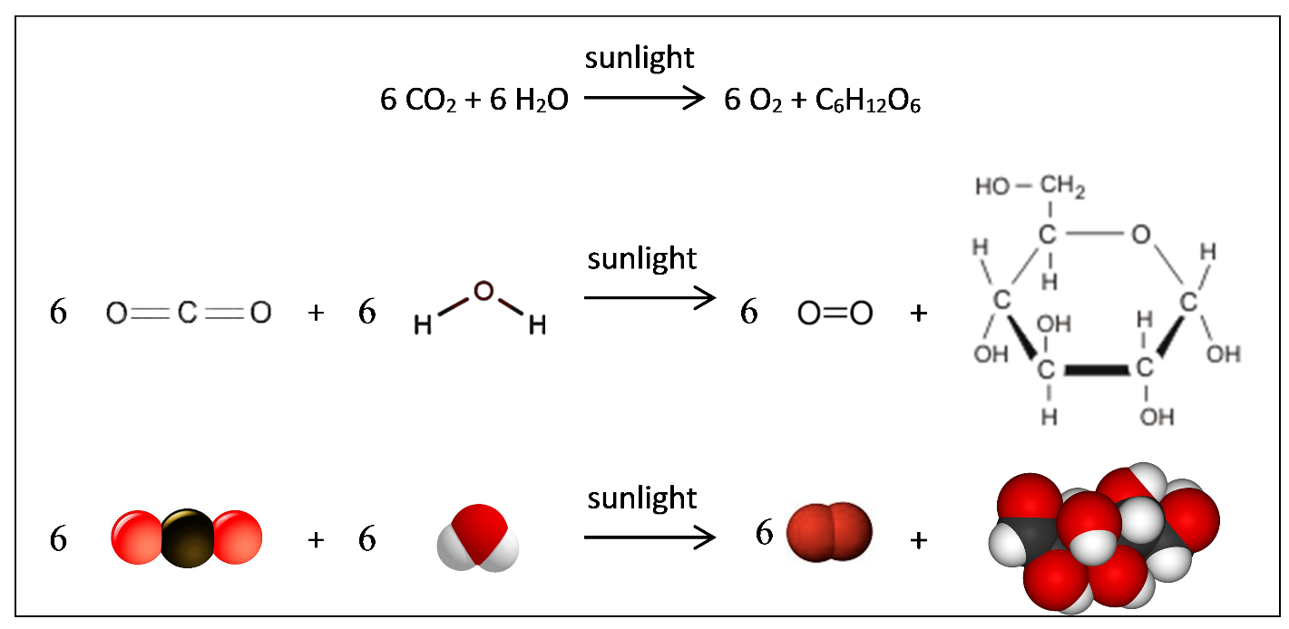

2a. This chemical equation shows that ________________ provides the energy needed to convert

__________________________ and _____________ to oxygen and the sugar glucose.

2b. Circle the three different representations of the sugar glucose.

3. Why Is photosynthesis a good name for this process?

4a. Conservation of matter is observed in all biological processes, including photosynthesis. Conservation of matter means that atoms are neither created nor destroyed. Which of the following chemical equations correctly shows conservation of matter?

sunlight
a. CO₂ + H₂O C₆H₁₂O₆ + O₂

sunlight
b. 6 CO₂ + 6 H₂O 6 C₆H₁₂O₆ + 6 O₂

sunlight
- 6 CO₂ + 6 H₂O C₆H₁₂O₆ + O₂

sunlight
d. 6 CO₂ + 6 H₂O C₆H₁₂O₆ + 6 O₂

4b. Next to each incorrect chemical equation, explain one way that this incorrect chemical equation violates conservation of matter.

Photosynthesis converts the energy in sunlight to chemical energy. This chemical energy becomes available when the glucose produced by photosynthesis reacts with O₂ to produce CO₂ and H₂O.

Another type of model of photosynthesis is an energy and matter flowchart. The energy and matter flowchart emphasizes that:
- One type of energy can be converted to another type of energy.
- One type of matter can be converted to another type of matter; i.e. the atoms in the input molecules are reorganized as the atoms in the output molecules.
- Energy is not converted to matter and matter is not converted to energy.

5. Complete this flowchart to show how energy and matter change during photosynthesis.
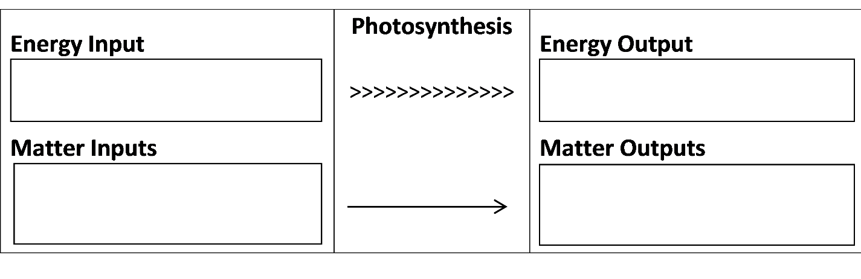

6. Return to the drawing in question 1 and make any corrections needed to provide a more accurate summary of photosynthesis.

Photosynthesis takes place in chloroplasts inside leaf cells. This diagram of a chloroplast shows some of the many steps involved in the process of photosynthesis. This diagram is another model of photosynthesis.

Each chloroplast contains many chlorophyll molecules. Chlorophyll molecules absorb light and help to convert light energy to chemical energy to begin the process of photosynthesis.

7a. In the figure, use an * to show where you would expect chlorophyll to be located.

7b. Write Input next to each arrow that shows an input for photosynthesis.

7c. Write Output next to each arrow that shows an output produced by photosynthesis.

7d. Use an R to indicate the arrows that represent the chemical reactions that use CO₂ molecules and H atoms to make sugars.

8. Based on the chloroplast diagram, describe the major steps in the process of photosynthesis.

9. What are some features of photosynthesis that are shown in all three types of model (the chemical equation on page 1, the energy and matter flowchart on page 2, and the chloroplast diagram on this page)?

10. Different types of models have different advantages for understanding photosynthesis. In the table below, describe an advantage of each type of model. How does this type of model contribute to your understanding of photosynthesis?

An advantage of the
chemical equation

An advantage of the
energy and matter flowchart

An advantage of the
chloroplast diagram

s

By Dr. Ingrid Waldron, Dept Biology, Univ Pennsylvania, © 2017. This Student Handout (can be copied for classroom use) and Teacher Notes (with background information and instructional suggestions) are available at http://serendip.brynmawr.edu/exchange/bioactivities/plantmass.

