Aquatic Ecosystems Drawing
Lakes and Ponds:
DRAW a lake ecosystem and LABEL the following on your picture:
Littoral zone, Benthic zone, decomposers, phytoplankton and zooplankton. Out to the side of your picture describe what each of these are as well as their importance.

Estuaries:

DESCRIBE what an estuary is.

DRAW a picture of an estuary, and LABEL how fresh water and salt water mix. Below your picture, SUMMARIZE how the different types of water mix and WHY this is significant in TWO sentences.

Ocean Zones:
DRAW a picture of an ocean and label the following zones: shallow ocean waters, ocean surface, and deep ocean waters. Below your picture, DESCRIBE what each of these zones is like. GIVE EXAMPLES of at least THREE organisms (plants or animals) that might live in EACH zone.

Coral Reefs:
COLOR in all the areas of the world where coral reefs can be found.
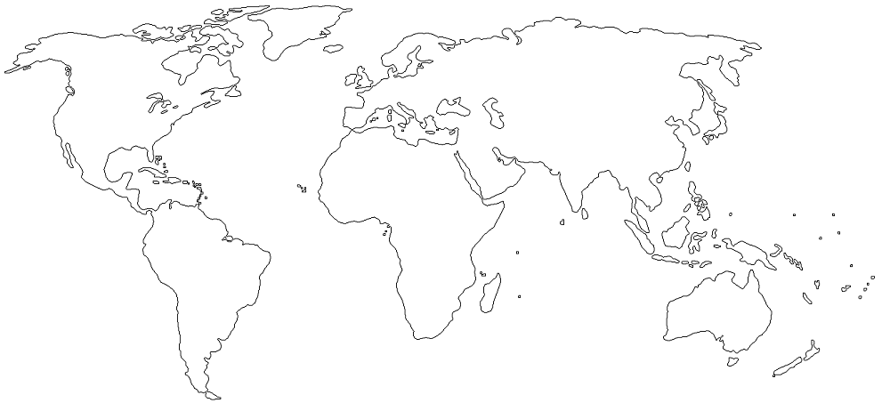
DEFINE coral bleaching.

LIST THREE things that have been linked to the destruction of coral reefs:

