Ecological Succession Readings and Practice
Name __________________________________ Date ________ Period _______
Part 1: Ecological Succession

Ecosystems constantly change. A tree falling in a forest affects the forest ecosystem. A fire might alter the forest habitat so much that some species cannot survive and others can thrive. The process of one community replacing another as a result of changing abiotic and biotic factors is called ecological succession.

How does soil form in primary succession?

There are two types of ecological succession – primary and secondary succession. Primary succession is the establishment of a community in an area of bare rock that does not have topsoil. For example, suppose a lava flow alters an ecosystem. The lava hardens to form bare rock. Usually, lichens begin to grow on the rock first. Because lichens and some mosses are among the first organisms to appear, they are called pioneer species.

Pioneer species secrete acids that help break down rocks. As pioneer species die, their decaying organic materials mix with small pieces of rock. This is the first stage of soil development. Small weedy plants begin to grow in the soil. These organisms die, adding to the soil. Seeds brought by animals, water, and wind begin to grow. Eventually, enough soil forms to support trees and shrubs.

It might take hundreds of years for the ecosystem to become balanced and achieve equilibrium. When an ecosystem is in equilibrium, there is no net change in the number of species. New species come into the community at about the same rate that others leave the community. This is a climax community – a stable, mature community in which there is little change in the number of species.

How does secondary succession occur?

Disturbances such as fire or flood can disrupt a community. After a disturbance, new species of plants and animals might occupy the habitat. Over time, the species belonging to the climax community are likely to return. Secondary succession is the orderly and predictable change that takes place after a community of organisms has been removed but the soil remains. Pioneer species begin the process of restoring a habitat after a disruption. The figure below shows how the community changes after a forest fire, leading again to a mature climax community.

Part 1: Comprehension Questions

- What are two things mentioned in the reading that can happen that might affect an ecosystem?

- Define ecological succession.

- What is primary succession?

- Describe an example of primary succession.

- What is a pioneer species?

- How long might it take for an ecosystem to become balanced?

- What happens when an ecosystem is in equilibrium?

- Define climax community.

- Name two things that can disrupt a community.

- What is secondary succession?

Part 2: Succession in Aquatic Environments
Succession, a series of environmental changes, occurs in all ecosystems. The stages that any ecosystem passes through are predictable. In this activity, you will place the stages of succession of two ecosystems into sequence. You will also describe changes in an ecosystem and make predictions about changes that will take place from one stage of succession to another.
The evolution of a body of water from a lake to a marsh can last for thousands of years. The process cannot be observed directly. Instead, a method can be used to find the links of stages and then to put them together to develop a complete story.
The water level of Lake Michigan was once 18 meters higher than it is today. As the water level fell, land was exposed. Many small lakes or ponds were left behind where there were depressions in the land. Below are illustrations and descriptions of four ponds as they exist today. Use the illustrations and descriptions to answer the questions about the ponds.
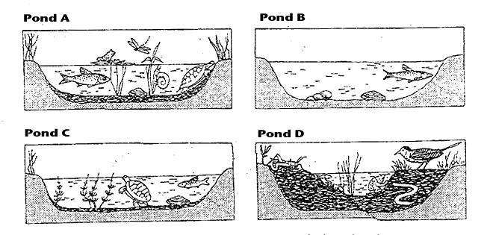
Pond A:
Cattails, bulrushes, and water lilies grow in the pond. These plants have their roots in the bottom of the pond, but they can reach above the surface of the water. This pond is an ideal habitat for the animals that must climb to the surface for oxygen. Aquatic insect larvae are abundant. They serve as food for larger insects, which in turn are food for crayfish, frogs, salamanders, and turtles.
Pond B:
Plankton growth is rich enough to support animals that entered when the pond was connected to the lake. Fish make nests on the sandy bottom. Mussels crawl over the bottom.
Pond C:
Decayed bodies of plants and animals form a layer of humus over the bottom of the pond. Chara, branching green algae, covers the humus. Fish that build nests on the bare bottom have been replaced by those that lay their eggs on the Chara.
Pond D:
The pond is so filled with vegetation that there are no longer any large areas of open water. Instead, the pond is filled with grasses. The water dries up during the summer months.
Questions:
1. Write the letters of the ponds in order from the youngest, to the oldest.

2. Black bass and bluegill make their nests on sandy bottoms. In which pond would you find them?

3. What will happen to the black bass and blue gill as the floor of the ponds fills with organic debris?

4. Golden shiner and mud minnows lay their eggs on Chara (green algae). In which pond would you find them?

5. Some amphibians and crayfish can withstand periods of dryness by burying themselves in mud. In which pond(s) would they survive?
6. Dragonfly nymphs spend their early stages clinging to submerged plants. Then, they climb to the surface, shed their skins, and fly away as dragonflies. Which pond is best suited for dragonflies?
7. In which pond will gill breathing snails be replaced by lung breathing snails that climb to the surface to breathe?
8. Some mussels require a sandy bottom in order to maintain an upright position. In which pond will they die out?
The climax community in the area of Arkansas is an oak-hickory forest. After the ponds are filled in, the area will undergo another series of stages of succession. This is illustrated below. Briefly explain what is happening in the diagram.
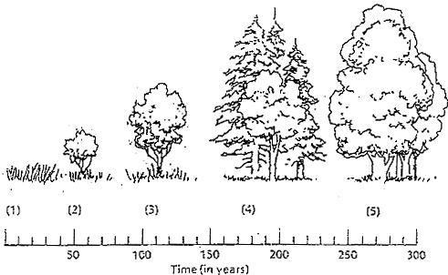
1.

2.

3.

4.

5.

