What is a population?
- Define population. Provide an example.

- Why is a population a reproductive group?

- The word population refers to the group and the ________________ of the population.
Properties of Populations
- What are the three ways that populations can be described?

- Define density.

- Define dispersion.

- What are the three types of dispersion?

How does a Population Grow?
- How does a population gain and lose individuals?

- What is growth rate? Fill in the formula for growth rate.

- What happens to growth rates over time? Why?

- Growth rates can be ___________________, _____________________ or _____________.
- What would need to happen for the growth rate to be zero?

How Fast can a Population Grow?
- How many eggs may a female sea turtle lay in her lifetime?

- What would happen if all of the eggs survived?

- What do populations usually do? Why?

- What is a species biotic potential?

- What limits biotic potential? Define the term.

- What is the difference between the reproductive rates of elephants and bacteria?

- What three factors contribute to the reproductive potential?

- Which has the greatest effect? Why?

- What is exponential growth? Draw a generic graph in the box.

- How does exponential growth occur?

What Limits Population Growth?
- Why do populations not grow forever or grow at their reproductive potential?

- What is carrying capacity?

- How does a species reach its carrying capacity?

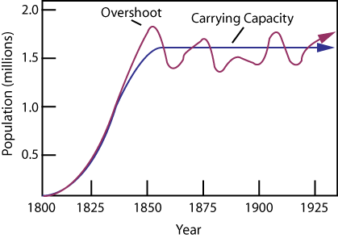
- What is limiting resource?

- Why do species compete with one another in a population?

- Member of a species may compete indirectly for _________________ _____________________ or for a ___________________________.

- What is a territory?

- Why is a territory valuable?

Two Types of Population Regulation
- What is density dependent? Provide some examples.

- What is density independent? Provide some examples.

- Define niche.

- List the 5 major types of species interactions:

- What is competition? Give an example.

- What is niche restriction?

- Describe predation. Give an example.

- Define parasitism. Give an example.

- Compare and contrast predators and parasites.

- What is mutualism? Give an example.

- What is commensalism? Give an example.

- What is coevolution? Give an example.

