Practice-Animal Cell
Apalachee High School, Biology
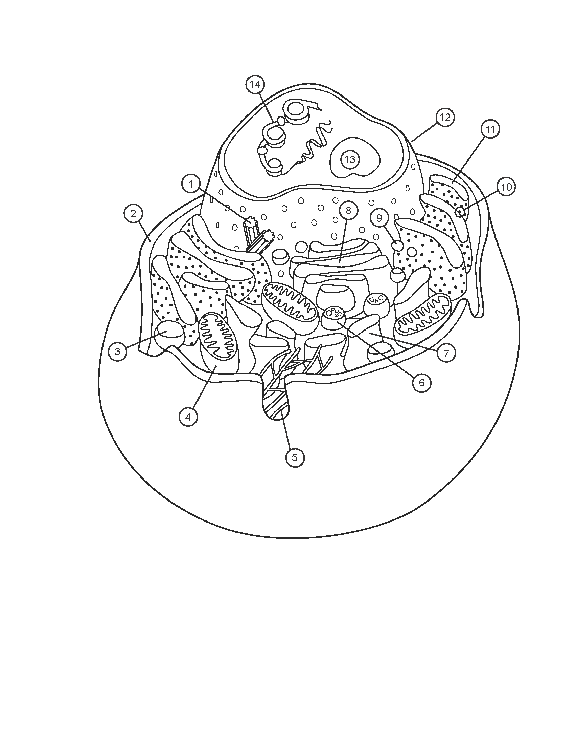
Directions: Color and Label the parts

- ___________________________________
- ___________________________________
- ___________________________________
- ___________________________________
- ___________________________________
- ___________________________________
- ___________________________________

- ___________________________________
- ___________________________________
- ___________________________________
- ___________________________________
- ___________________________________
- ___________________________________
- ___________________________________

Practice-Plant Cell
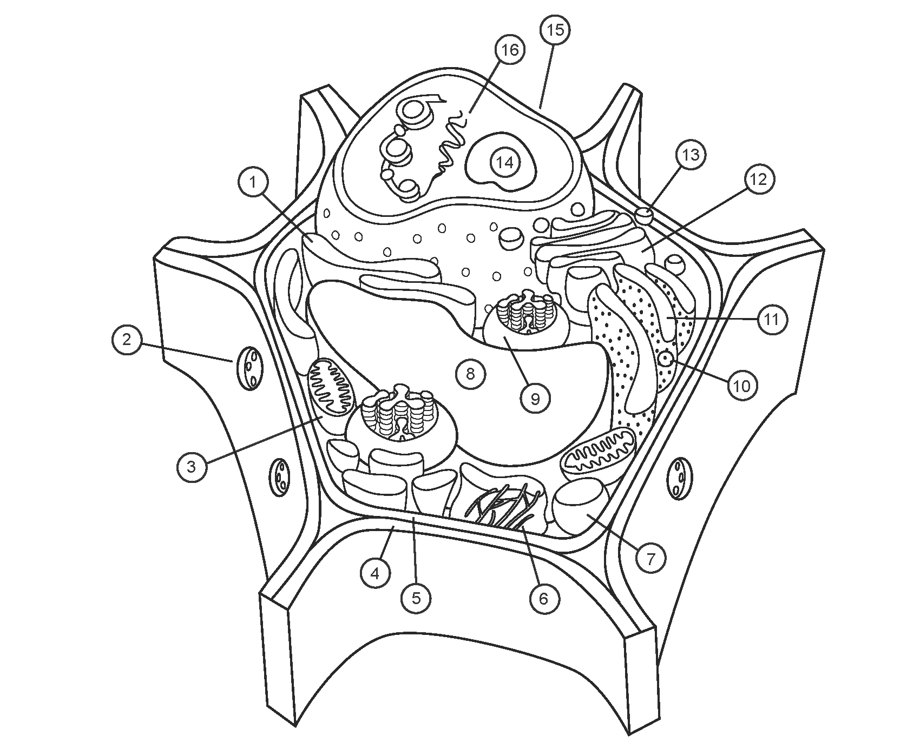
Apalachee High School, Biology

Directions: Color and Label the parts.

- ___________________________________
- ___________________________________
- ___________________________________
- ___________________________________
- ___________________________________
- ___________________________________
- ___________________________________
- ___________________________________
- ___________________________________
- ___________________________________
- ___________________________________
- ___________________________________
- ___________________________________
- ___________________________________
- ___________________________________
- ___________________________________

Directions: Define the following parts of the animal cell.
- Centromeres
- Cytoskeleton
- DNA
- Golgi Body
- Lysosomes
- Mitochondria
- Nucleolus
- Nucleus
- Peroxisomes
- Plasma membrane
- Ribosomes
- Rough ER
- Smooth ER
Directions: Define the following parts of the plant cell.
- Cell Wall
- Chloroplast
- Cytoskeleton
- DNA
- Golgi Complex
- Mitochondria
- Nucleolus
- Nuclues
- Perixosomes
- Plasmodesmata
- Ribosomes
- Rough ER
- Smooth ER
- Vacoule

- Vesicles

